A Primer on the

Names and Namesakes of

Charlottesville City Schools

**License** **3**

**Introduction** **4**

**Summary** **6**

**Timeline** **8**

**Venable Elementary (1925)** **11**

**George Rogers Clark Elementary (1931)** **23**

**Johnson Elementary (1954)** **26**

**Burnley-Moran Elementary (1954)** **29**

**Greenbrier Elementary (1962)** **36**

**Walker Upper Elementary (1966)** **37**

**Buford Middle (1966)** **40**

**Jackson-Via Elementary (1969)** **43**

**Charlottesville High (1974)** **49**

**Lugo-McGinness Academy (2014)** **50**

**City Public Schools, 1920-1921** **52**

**References** **54**

**Document Revision History** **57**

# License

The text in this document is released under the license Creative Commons CC0 1.0 Universal. The text of this license can be found at <https://creativecommons.org/publicdomain/zero/1.0/legalcode>.

This license allows for use without restriction and without attribution.

# Introduction

In order to ask ourselves who we are as a community today and who we want to be in the future, we must know who we have been as a community in the past. And like most school districts, the names of the Charlottesville City Schools provide us with a window into that past, as many of the buildings have been named after one or more individuals who occupy parts of our shared history.

Current facilities naming policy (FFA-R), which can, but does not have to, be used for naming new schools indicates that this should be (1) for “a significant contribution to the division,” and (2) that the person will have made a “lasting impact” that was “exceptional and well beyond expectation.” The FFA-R naming policy also stipulates that a school may be considered for renaming if “a future nominee matches and/or exceeds those standards of the person(s) or business(s) for whom the facility is currently named.”

As detailed in this document, George Rogers Clark is the only school namesake who has no connection to the school division. Evaluating the other naming criteria, however, is more complex. This document is meant to serve as a primer. It is not exhaustive, and an official study is warranted if the City, CCS, and the School Board desire to thoroughly examine our school namesakes.

In some ways, the names of our city schools embody and reflect the contradictions and conflict we continue to struggle with today: those of power, racism, sexism, and narrative. For example, both Rebecca Fuller McGinness’s father, Charles S. Fuller, and Nannie Cox Jackson’s mother, Elizabeth Scott, were enslaved in the South. Whereas Col. Charles S. Venable enthusiastically fought beside Gen. Robert E. Lee and the fathers of Carrie Burnley, Sarepta Moran, and James G. Johnson in the Confederate Army, which sought to preserve the system of race-based enslavement. Further, McGinness’s great-grandmother was Cherokee, a Native American nation that Clark made a career fighting and killing.

Assessing the beliefs, actions, and accomplishments of historical figures is difficult. When we evaluate the individuals and reasons behind their memorialization, we must consider their entire life.They lived in a different time, and had different systems of value than we have today. We have this paradox: systems of power and control would not exist if people did not individually participate and support them, and yet in order to participate in these systems, people chose to conform to them.

Unlike grand monuments or places named for the notorious, with many of our schools we have a genuine opportunity to engage in a dialogue with the past. The names of these schools are no longer simply a memorialization to an individual, but a set of memories to past students (many good, many painful), and a significant part of the lives of current students and parents, for better and worse. We have the opportunity to turn history from being a series of past events to an open acknowledgment and examination of how it manifested in our community, frequently in very painful ways. It is work we must do.

# Summary

* There are 10 city schools, with 13 namesakes.
* They are named for: 11 people (4 white men, 4 white women, 3 Black women, 0 Black men) and 2 places.
* Of these 11 people: At least 2 of the Black women had parents who were enslaved by white people, at least 2 of the white men were directly involved in enslaving Black people, and at least 3 of the other white namesakes, perhaps as many as 6, had immediate family members who enslaved Black people.

* **Venable Elementary** (1925) is named for **Lieutenant Colonel Charles S. Venable (1827–1900)**. Venable served as aide-de-camp to Gen. Robert E. Lee from 1862 until 1865. He was a professor at the UVA for 40 years, writing several math textbooks and serving on the City School Board for six years.
* **George Rogers Clark Elementary** (1931) is named for **Brigadier General George Rogers Clark** (1752 – 1818). Clark was born in Albemarle County near the school building. He served as an officer during the Revolutionary War and the Northwest Indian War (Little Turtle’s War).
* **Johnson Elementary** (1954) is named for **Dr. James G. Johnson** (1871-1957). Johnson received his Ph.D. in English from UVA in 1909, then became Superintendent of Schools, holding that position until 1946.
* **Burnley-Moran Elementary** (1954) is named for **Carrie Burnley** (1864-1954) and **Sarepta Moran** (1875-1961). **Burnley** worked in City schools for 50 years, teaching at all levels and as principal of McGuffey for 28 years. **Moran** worked in City schools for 48 years, first as a teacher, then as assistant principal at Midway, then as the first principal of Venable, working there for 21 years.
* **Greenbrier Elementary** (1962) is named for the Greenbrier neighborhood.
* **Walker Upper Elementary** (1966) is named for **Haswell Hunter Walker** (1896-1992). Walker worked at Midway/Lane High for 42 years as a math teacher for all but three of those years when he was principal.
* **Buford Middle** (1966) is named for **Florence De Launey Buford** (1893-1974). Buford worked in City schools for 37 years, first as a teacher at Midway for four years, then as the first principal of Clark until her retirement.
* **Jackson-Via Elementary** (1969) is named for **Nannie Cox Jackson** (1865-1953) and **Betty Davis Via** (1901-1993). **Jackson** taught in the City for 25 years at the Jefferson School, out of a 46 year career. **Via** worked in City schools for 38 years, first as a teacher at Venable, becoming principal in 1945, then as the first principal of Johnson Elementary for 10 years.
* **Charlottesville High** (1974) is named after the city of Charlottesville, which itself is named after **Charlotte of Mecklenburg-Strelitz**, queen consort of King George III.
* **Lugo-McGinness Academy** (2014) is named after **Alicia Inez Bowler Lugo** (1941-2011) and **Rebecca Fuller McGinness** (1892-2000). **Lugo** served as a teacher and administrator in the City for several years, on the School Board for 11 years, on numerous local Boards of Directors, and received numerous awards in recognition of her service to the community. **McGinness** taught at the Jefferson School for over 40 years, served in more than a dozen community organizations, such as the Order of the Eastern Star, Church Women United, and the Thalian Art and Literary Club.

# Timeline

* **Pre-1700** - Monacans lived, hunted, and traveled in this area for thousands of years
* **1743** - Thomas Jefferson born in Shadwell, Virginia
* **1752** - George Rogers Clark born in Albemarle County, Virginia
* **1818** - George Rogers Clark dies in Kentucky
* **1826** - Thomas Jefferson dies in Albemarle County, Virginia
* **1865** - Civil War ends
* **1865** - Jefferson Training School established for Black students and teachers
* **1873** - William H. McGuffey dies in Charlottesville, Virginia
* **1877** - Charlottesville High School is founded as the first white public high school in the city. It closes in 1882.
* **1894** - Jefferson Graded School (grades 1-6) constructed along Fourth St NW for Black students and teachers
* **1894** - Midway School (grades 1-11) constructed along Ridge and West Main for white students and teachers
* **1896** - U.S. Supreme Court establishes “separate but equal” doctrine with *Plessy v. Ferguson* ruling
* **1900** - Col. Charles S. Venable dies in Charlottesville, Virginia
* **1909** - Confederate Soldier Memorial consisting of the statue *At the Ready* and two cannons installed at Albemarle County Courthouse by committee chaired by Mary Southall Venable, wife of Col. Charles S. Venable
* **1916** - McGuffey Primary opens
* **1918** - Lee Park (segregated, white-only), now named Market Street Park, donated by Paul G. McIntire, on the site of the Southall-Venable House
* **1919** - Jackson Park (segregated, white-only), now named Court Square Park, donated by Paul G. McIntire after a Black neighborhood is razed and destroyed
* **1919** - *Their First View of the Pacific* statue of Sacagawea, William Clark, and Meriwether Lewis erected at the intersection of Ridge St. and Main St., funded by Paul G. McIntire
* **1921** - *George Rogers Clark* statue erected on what is now part of the Grounds of the University of Virginia, at the intersection of West Main St. and Jefferson Park Ave., funded by Paul G. McIntire
* **1921** - *Thomas Jonathan Jackson* statue of Gen. T. J. “Stonewall” Jackson erected in Court Square, funded by Paul G. McIntire
* **1924 May** - *Robert Edward Lee* equestrian statue erected on Market St., funded by Paul G. McIntire
* **1924 November** - School board names new white primary school for Col. Charles S. Venable. Midway High renamed for James W. Lane. (The names for the Midway School Building and the Midway Grammar School are retained)
* **1925 September** - Venable Primary School opens
* **1925** - Jefferson High School (grades 7-11) constructed adjacent to Jefferson Graded School, both for Black students, opens the next year
* **1931 September** - George Rogers Clark School opens
* **1940** - The white-only Lane High moves to a new building, also named Lane High School, in what is now the Albemarle County Office Building, on the site of former Black neighborhood that is razed for this purpose
* **1951** - Jackson P. Burley High School opens as a Black-only school serving both Albemarle and Charlottesville students, in an attempt to provide more equal facilities to forestall desegregation
* **1954** - *Brown v. Board of Education of Topeka* ruling strikes down *Plessy v. Ferguson* “separate but equal” segregation doctrine. Brown includes the case *Davis et al. v. County School Board of Prince Edward County*, which attempted to address the poor conditions at the Black-only Moton High School in Farmville, Va.
* **1954** - Johnson Elementary and Burnley-Moran Elementary open for white students and teachers
* **1955** - *Brown II* orders school districts to desegregate “with all deliberate speed”
* **1956** - Virginia General Assembly passes “Massive Resistance” laws, advocated for by U.S. Senator Harry F. Byrd, Sr., allowing the State to close white schools that desegregate
* **1958 September** - Judge John Paul orders the Charlottesville School Board to admit nine Black students to Venable and three Black students to Lane
* **1958 September** - Charlottesville delays schools opening while appealing the Paul order in an attempt to forestall integration
* **1958 September** - Virginia Gov. J. Lindsay Almond orders Venable and Lane to close before they desegregate as part of Massive Resistance
* **1958** - Robert E. Lee Elementary School and the Rock Hill Academy are founded as private, white-only schools known as Segregation Academies.
* **1959 February** - Court orders Venable and Lane to reopen while a plan for desegregation is formed, but schools remain segregated and the twelve Black student plaintiffs take classes at the School Board office instead of their court-ordered assignments at Lane or Venable.
* **1959 September 5th** - Judge Paul orders immediate transfer of the Charlottesville Twelve to Venable and Lane.
* **1959 September 8th** - Charlottesville Twelve attend formerly all-white Venable and Lane schools, beginning the desegregation of Charlottesville city schools. The students assigned to Venable attend class in an annex behind the main building. School assignments are still mostly segregated; transferring between schools is difficult, and in 1960 only one additional Black student applies for a transfer.
* **1960** - Gaining momentum since 1949, the destruction of Vinegar Hill begins, as part of the city’s white-led Urban Renewal movement. Neighborhood eviction and demolition continues until 1965, decimating the center of Black business and displacing many residents, some to newly-opened public housing in Westhaven
* **1962** - Greenbrier Elementary opens
* **1962** - Johnson Elementary is desegregated when Black students Karol Williams, Scheryl Williams, Michael Lewis, and Rosalind Whitlock begin attendance after court order.
* **1965** - Explicit race-based school segregation of both students and teachers ends, with new geographically-based attendance boundaries for the 1965-66 school year
* **1966** - Walker and Buford open as junior high schools
* **1966** - Jefferson School closes, and all Black students are required to attend formerly white-only schools
* **1969** - Jackson-Via Elementary opens, the first school named for an African American teacher (Nannie Cox Jackson)
* **1973** - McGuffey School closes as a public school
* **1974** - Charlottesville High opens, retaining the Lane “Black Knights” mascot
* **2014** - Lugo-McGinness Academy named

# Venable Elementary (1925)

*The school was named for Colonel Charles Scott Venable, who was a Civil War soldier, professor of mathematics at the University of Virginia and author of arithmetic books for children.*

-- About Venable Elementary School, <http://charlottesvilleschools.org/venable/us>

See Cvillepedia entry on [Venable Elementary School](https://cvillepedia.org/Venable_Elementary_School), entries about Charles S. Venable in [Cvillepedia](https://cvillepedia.org/Charles_Scott_Venable), [Encyclopedia Virginia](https://encyclopediavirginia.org/Venable_Charles_S_1827-1900) and [Wikipedia](https://en.wikipedia.org/wiki/Charles_S._Venable), and a family tree on [WikiTree](https://www.wikitree.com/wiki/Venable-208).

Venable Elementary is named for **Lieutenant** **Colonel Charles Scott Venable (1827–1900)**. Col. Venable was born in Farmville, Virginia in 1827 to a white family that enslaved Black people. He matriculated from the University of Virginia in 1845, and proceeded to teach at Hampden-Sydney College, the University of Georgia, and the University of South Carolina before joining the Confederate cause. In 1858, three years before the start of the Civil War, Venable gives a speech to UVA alumni in which he defends the South and slavery.

In 1861, he was a professor at South Carolina College (now University of South Carolina). He joined the Congaree Rifles militia and encouraged his students leave college and join Confederate military units. As part of this militia, he was present in 1861 at the Battle of Fort Sumter, which began the Civil War. Venable soon became an officer in the newly-formed Confederate States Army, then served as **aide-de-camp** in the small personal staff of **Gen. Robert E. Lee** from 1862 until surrender in 1865. From then on he preferred to use the honorific “Colonel,” instead of “Professor” or “Doctor.”

Primarily because of his association with Lee, including a personal letter of recommendation from him, Venable was offered a position as a Professor of Mathematics at the University of Virginia. Venable taught at UVA for the next 40 years, and served as Chairman of the Faculty for several years during that time. He wrote a number of mathematics textbooks which were adopted in Virginia schools and served on the Charlottesville School Board for six years.

After the Civil War, as secretary of the Association of the Army of Northern Virginia, Venable was an “important voice among those promoting the Lost Cause interpretation of the Civil War,” which “sought to discount the importance of slavery and emphasize the valor of Confederate soldiers.”[1] The Lost Cause also gave rise to the era of racial terror known as Jim Crow, the miseducation of generations, and the perpetuation of the myth of white racial supremacy.

When Venable Primary School was named in late 1924, the existing, segregated public schools in Charlottesville were Midway School (grades 1-11, white), McGuffey Primary School (grades 1-7, white), and Jefferson Colored School (grades 1-7, Black). Midway was named after Alexander Garrett’s former plantation house, which sat nearby and where he enslaved more than 60 Black people,and Jefferson was named after Thomas Jefferson. McGuffey Primary School was named in 1916 for William Holmes McGuffey, a professor of Philosophy at UVA, who wrote the McGuffey Readers, “the first widely used series of elementary school-level textbooks... [selling] more than 120 million copies... between 1836 and 1960.”[2]

At the October 16, 1924 Charlottesville School Board meeting, the three-man naming committee recommended naming the new school “Venable” by a vote of 2-1, with one of the yes votes coming from Dr. Thomas L. Watson, Professor of Geology at UVA. Both Watson’s father, Fletcher B. Watson, and uncle, Wilbur F. Watson, served in the Virginia 6th Cavalry Regiment, Confederate States Army. As relayed in The Daily Progress the next day, “Mr. Paul G. McIntire spoke in favor of honoring the name and work of Col. Charles S. Venable by naming the new school for him.”

At the Nov. 20, 1924 Charlottesville School Board meeting, the Board voted 7-3 to name the new school “Venable Primary School.”

The Daily Progress, Aug. 11, 1900, front page, Col. Charles S. Venable obituary

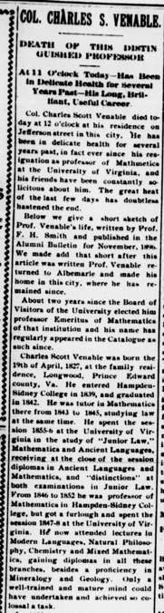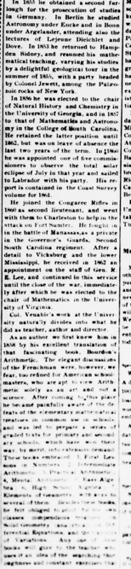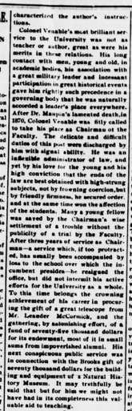

The Times (Richmond), Aug 12, 1900, front page

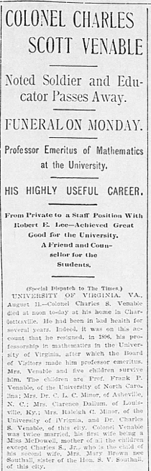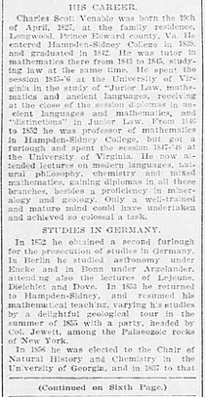

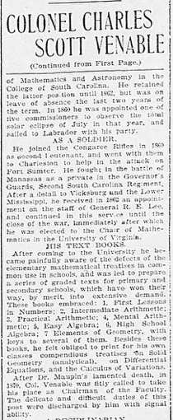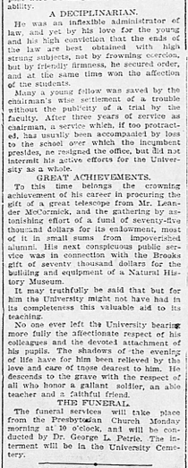

The Daily Progress, Aug. 13, 1900, front page, Col. Charles S. Venable funeral

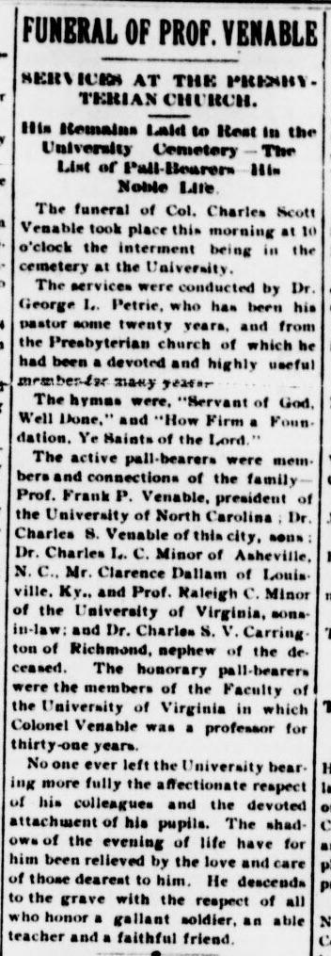

Selections about Charles Venable:

“Whiling away long hours conversing with States Rights Gist, James and Mary Chesnut, and other notables, Venable often expressed both his disgust at the northerners who were waging war against ‘Christian’ slavery and those who sought commissions in the Confederate army behind the lines.”[3] -- *Mary Chesnut’s Civil War*

“[By 1867], he proposed a curriculum change to make the mathematics program more flexible, and staunchly opposed any attempt to open the university [of Virginia] to black students”[4] -- *Memoir* byF. P. Venable, Barbour Family Papers, and Charles S. Venable Papers

“[Venable] derided the idea of giving freedmen the vote, expressing thanks that Virginia had escaped the ‘black dominion’ of military Reconstruction, and derided the idea of blacks attending the University of South Carolina as ‘the Fetish of abolitionists.’ Finally, he summarized Reconstruction itself as ‘the cruel crotchets of a sentimental philanthropy.’”[5] -- *Reconstruction: America’s Unfinished Revolution* by Eric Foner

“Similarly, although Charles Venable felt the necessity of preserving heroic memories of the Confederacy, he was too preoccupied with personal and professional matters to participate in most public efforts to promote the ‘Lost Cause.’ He continued to correspond with other former Confederate officers... and joined local historical associations to promote Confederate memory, writing that, ‘I esteem highly the work of such societies in collecting and preserving the materials for local and state histories.’ Because of his Confederate sympathies, Wade Hampton offered him the presidency of the University of South Carolina in 1882.”[6] -- Charles S. Venable Papers

The Daily Progress, Sept. 24, 1924, Community League recommends naming the new primary school “The James Lane Memorial School”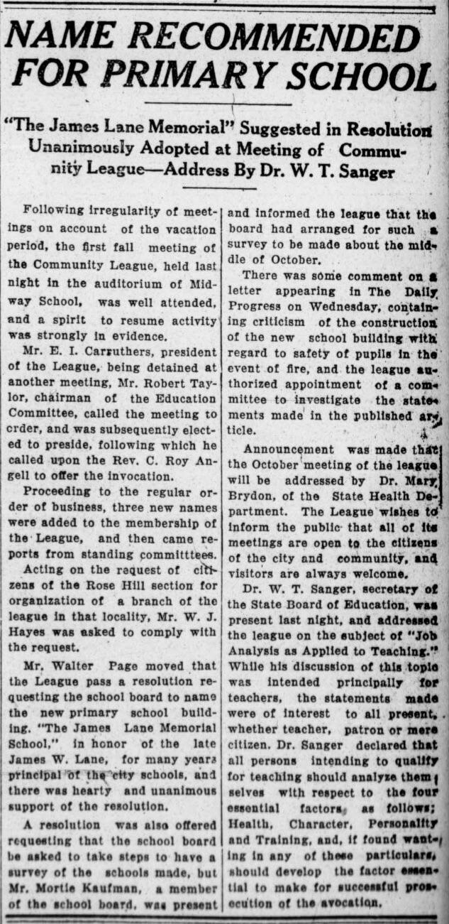

The Daily Progress Oct. 17, 1924, announcing the postponement of naming the new primary school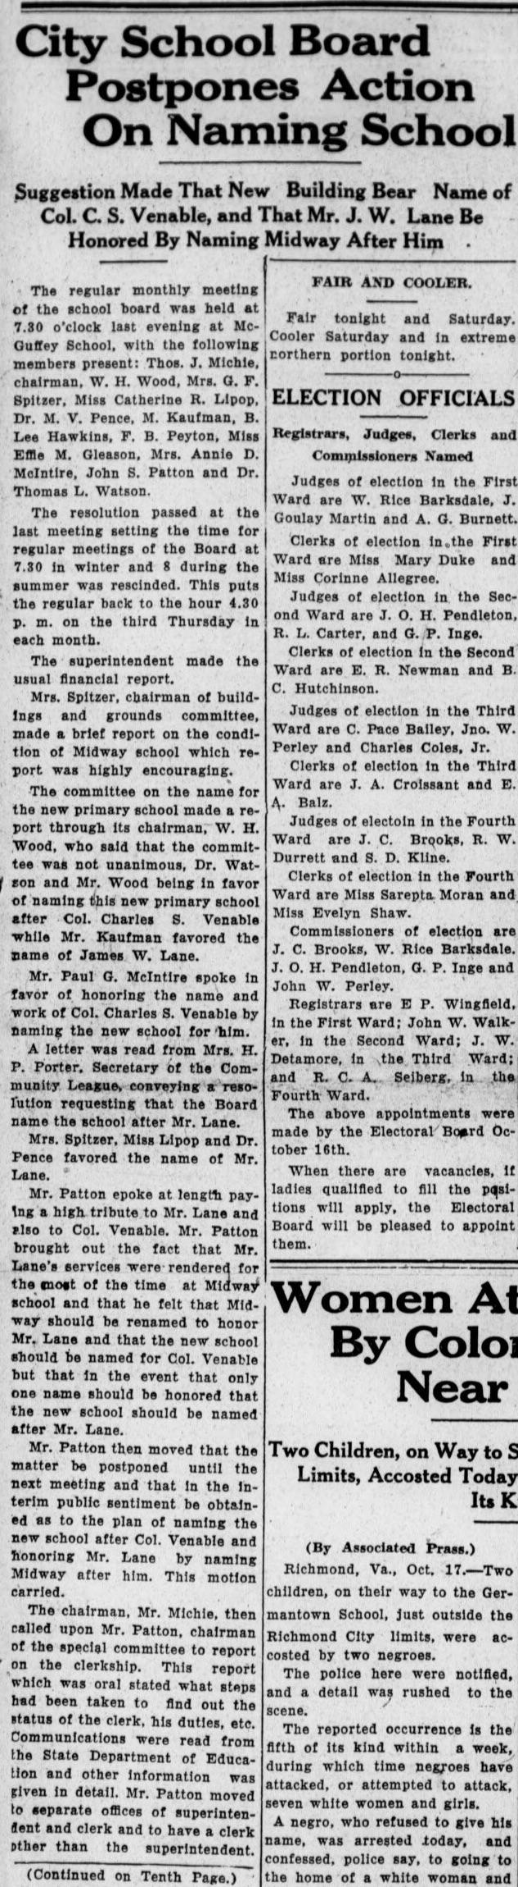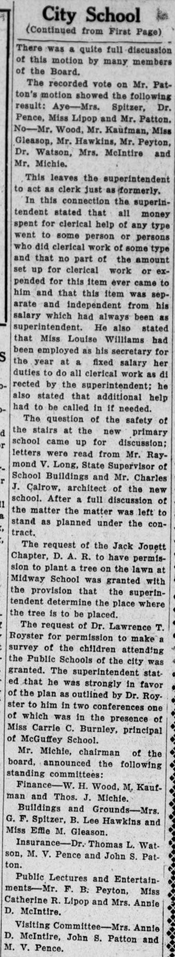

The Daily Progress, Nov. 21,1924, announcing the naming of Venable Primary School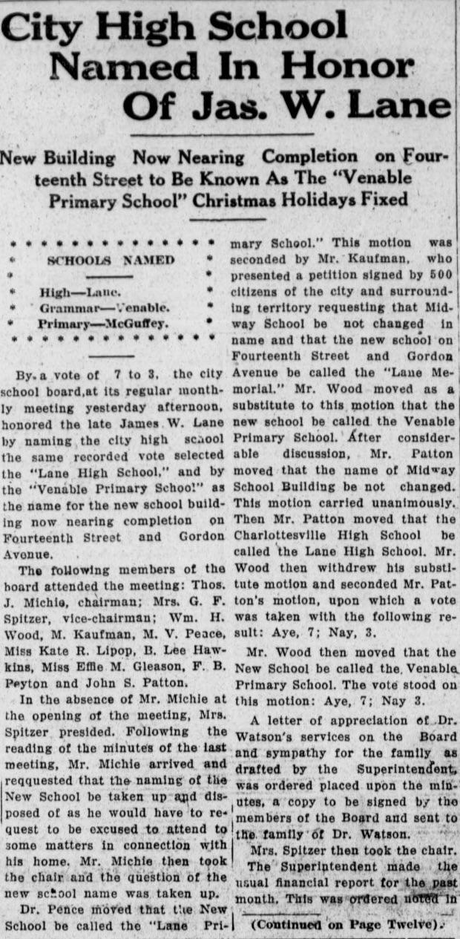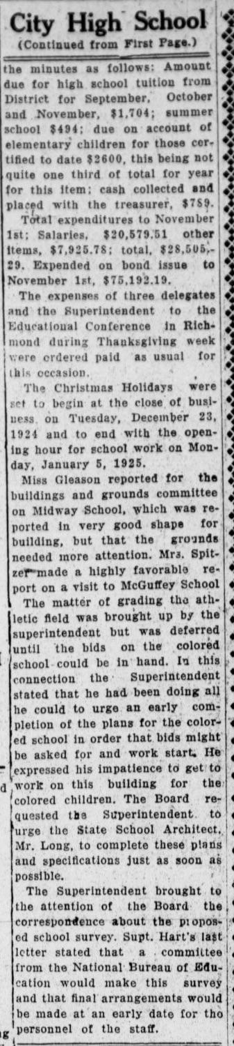

# George Rogers Clark Elementary (1931)

*The school is named for George Rogers Clark, the American frontiersman and Revolutionary War general. (Clark’s younger brother William was half of “Lewis & Clark.”)* -- About Clark Elementary School, <http://charlottesvilleschools.org/clark/us>

See Cvillepedia entries on [Clark Elementary School](https://www.cvillepedia.org/Clark_Elementary_School) and [George Rogers Clark](https://www.cvillepedia.org/George_Rogers_Clark). There is a lengthy entry in [Wikipedia](https://en.wikipedia.org/wiki/George_Rogers_Clark) about Clark, as well as numerous books written about his life.

George Rogers Clark Elementary is named for **Brigadier General George Rogers Clark (1752 – 1818)**. It is the only school to contain the full name of the person for whom it was named. Clark was born in Albemarle County, near Charlottesville, in 1752, but soon moved to Caroline County, where his family enslaved Black people on a 2,000-acre plantation. He served as an officer in the Virginia Militia during the Revolutionary War and the Northwest Indian War (1785-1795, in which more than 1,000 Native Americans were killed. Soon after, Clark was given the nickname, “Conqueror of the Old Northwest”. In both of these conflicts, he primarily fought against Native American tribes allied with or led by the British.

Clark’s family enslaved many Black people on their plantations, and when Clark’s father John Clark III, died, he inherited several enslaved people as part of his father’s will:

*“I give and bequeath to my son George Rogers and to his heirs and assigns forever, one negro man named Lue, also one negro woman named Venice, with live, present, and future increase, except Peter.”[7]*

Peter was bequeathed to Clark’s younger brother, William Clark, who was a member of the Lewis and Clark journey.

During the Revolutionary War, Clark spent what today is estimated to be nearly $1 million on supplying his units, which the state of Virginia did not fully compensate him for, and he was forced to sell most of his property. This is one reason why Clark’s will has no mention of enslaved individuals, but why William Clark mentions George Rogers Clark in the Certificate of Freedom for Kitt, one of people William enslaved:

*“Be it known that Kitt, having served faithfully, and as the body servant of Genl. George R. Clark deceased, conducted himself for many years with entire approbation, is hearby liberated from any involuntary servitude…”*  Signed by William Clark, 31 March, 1818

Paul G. McIntire suggested to name the school after Clark because “his services to Virginia and the nation are well known.”[8] McIntire’s first wife, Edith Clark, was a descendant of George Rogers Clark’s father, John Clark III. McIntire had already funded the *George Rogers Clark* statue erected in 1921 on what is now part of the Grounds of the University of Virginia, at the intersection of West Main St. and Jefferson Park Ave. The 150th anniversary of the capture of Fort Sackville by Clark was in 1929, which brought renewed attention to his memorialization, including a statue erected in Fredericksburg that year by the Paul Revere Chapter of the Daughters of the American Revolution of Muncie, Indiana.

# Johnson Elementary (1954)

*Built in 1954, the school was named for Dr. James G. Johnson, who was Superintendent of Schools for 35 years, from 1909 to 1946.*

-- About Johnson Elementary School, <http://charlottesvilleschools.org/johnson/us>

See Cvillepedia entries on [James G. Johnson](https://cvillepedia.org/James_G._Johnson) and [Johnson Elementary School](https://cvillepedia.org/Johnson_Elementary_School)

Johnson Elementary is named for **Dr. James Gibson Johnson (1871-1957)**. Johnson was born in Elk Garden, Russell County, Virginia and later moved to Tennessee. His father, C. W. Johnson, was a physician and Confederate veteran.

He received his Bachelor’s degree from Milligan College in Tennessee, then his Ph.D. in English from UVA in 1909. That same year, he became Superintendent of Schools in Charlottesville, holding that position until his retirement in 1946.

He oversaw the construction of several schools, including McGuffey, Venable, Clark, Lane, and the initial part of Jefferson High. In 1936, he edited and contributed to a detailed history of the Charlottesville schools that was published as a supplement to the McGuffey Readers.

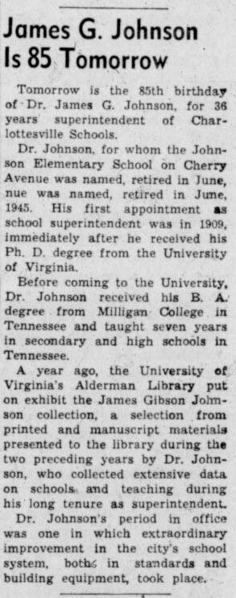

The Daily Progress, Feb. 4, 1956

The Daily Progress, June 21, 1957, obituary

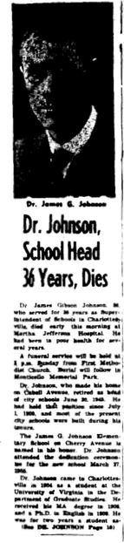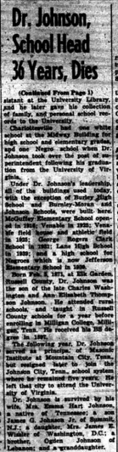

# Burnley-Moran Elementary (1954)

*Built in 1954, Burnley-Moran is named for the first two women to head Charlottesville schools. Carrie Burnley was principal of the former McGuffey School for 28 years, and Sarepta Moran was principal of Venable Elementary for 21 years.*

-- History of Burnley-Moran, <http://charlottesvilleschools.org/burnley-moran/>

See Cvillepedia entries on [Burnley-Moran Elementary School](https://www.cvillepedia.org/Burnley-Moran_Elementary_School) and [Carrie Burnley](https://www.cvillepedia.org/Carrie_Burnley) and [Sarepta Moran](https://www.cvillepedia.org/Sarepta_Moran)

Burnley-Moran Elementary is named for **Carrie Cornelia Burnley** and **Sarepta Anna Moran**, and opened only a few months after Burnley passed, and while Moran was still living.

**Carrie Cornelia Burnley** (1864-1954) was born in Albemarle County near Free Union, Virginia. She was one of five children born to Cornelia Winston Clarke and Drury Wood Burnley. Drury Wood Burnley was the son of Nathaniel Burnley, whose family enslaved more than 225 Black people in the Hydraulic Mills area, including the famous [Fountain Hughes](https://en.wikipedia.org/wiki/Fountain_Hughes).

For 50 of her 61-year career as an educator, Carrie Burnley taught at both the elementary and high school levels in Charlottesville. She was principal of the McGuffey School for 28 years, until age 80. She first cousin to Paul Goodloe McIntire, as their mothers were sisters.

Burnley began teaching at age 19 in a one-room schoolhouse near Mechum River. She then taught in Harrisonburg schools before teaching privately in Charlottesville. In 1894, she taught seventh grade in the inaugural year at the new Midway School. She later became assistant principal of the grammar division at Midway and, in 1911, moved to the high school division. In 1916, she was made the first female principal in the district at the new McGuffey primary school, and held that position for 28 years until her retirement in 1944.

Burnley was a member of the Albemarle Chapter of the United Daughters of the Confederacy (UDC), joining in 1907. The UDC was one of the most effective organizations at propagating the “Lost Cause” mythology, including the myth of white supremacy, most notoriously through the writing and editing of primary school textbooks. Our local chapter was also instrumental in erecting several monuments to Confederate soldiers, including the statue *At the Ready* at the Albemarle County Courthouse, the *Robert Edward Lee* equestrian statue, and the *Thomas Jonathan Jackson* (“Stonewall Jackson”) statue. While she was principal of McGuffey, she began a tradition of students decorating the Lee and Jackson monuments in downtown Charlottesville with flowers.

Burnley’s father, Sergeant Drury Wood Burnley, served as a member of the Albemarle (Virginia) Light Artillery, also known as Southall’s Battery, part of the Confederate States Army, from April 1861 until August 1862. This unit was founded and commanded by Captain William Henry Southall (1826-1890), brother of Mary Southall Venable, who was the second wife of Col. Charles S. Venable, Venable Elementary’s namesake, and who also served as chair of the committee overseeing the erection of the Confederate memorial statue *At the Ready* on Court Square in Charlottesville in 1909. Another of Mary Southall Venable’s brothers, S. V. Southall, was one of the Confederate veterans who endorsed Burnley’s application to the UDC.

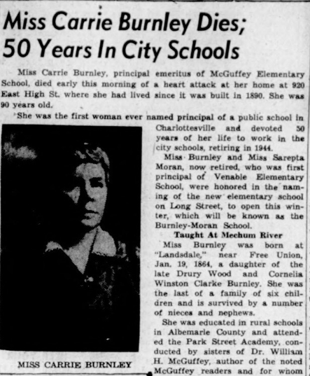

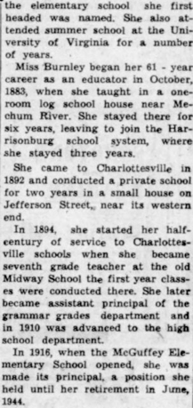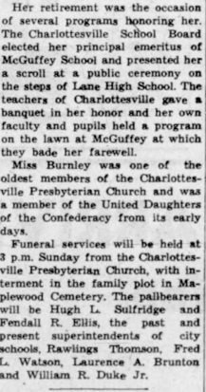

**Sarepta Anna Moran** (1875-1961) was an educator in Charlottesville schools from 1897 until her retirement in 1945. She was the first principal of Venable Elementary when it opened in 1925, and served in that role for 21 years. Note that Moran’s given name is frequently misspelled “Serepta.”

Sarepta Moran was born in Cairo, Illinois. She received a Master’s degree from Wesleyan Female Institute in Staunton, then became a teacher in Kentucky. In 1897, she began teaching in Charlottesville schools in the grammar division at Midway School, then moved to the high school division in 1905. In 1906, she studied at the Sorbonne in Paris, and later did other graduate work at several universities. From 1907 to 1923, she was assistant principal at Midway High, then became the first principal of Venable Elementary School when it opened in 1925, staying there until her retirement in 1946.

In 1924, the Midway High School yearbook was dedicated to her “high ideals, true sense of justice, refined culture and sincere devotion to her work.” In 1954, she received the Algernon Sydney Sullivan Award from UVA for her contributions as an educator.

For most of her adult life, Moran lived with her two sisters, Edna and Virginia, and their parents until their deaths, at 215 Montebello Circle, known as “Montebello,” now 1700 Stadium Road. None of the three sisters married, which was unusual for the time. Col. Charles S. Venable, for whom Venable Elementary School is named, owned the house from 1875-1887, and it was later purchased in 1914 as the “Montebello Mansion House” by Moran’s father, Issac Kimber Moran.

Moran was active in the Albemarle chapters of the Daughters of the American Revolution and the United Daughters of the Confederacy. Her father began serving the Confederate cause at age 16, prior to being old enough to join as a soldier, which he did in 1864 when the age limit was lowered to 17. Isaac K. Moran fought in Gen. Robert E. Lee’s Army of Northern Virginia, and was “desperately wounded in the battle of Drewry’s Bluff, causing amputation of left leg above the knee.[9]” I. K. Moran served as bursar of UVA from an unknown date until 1912.

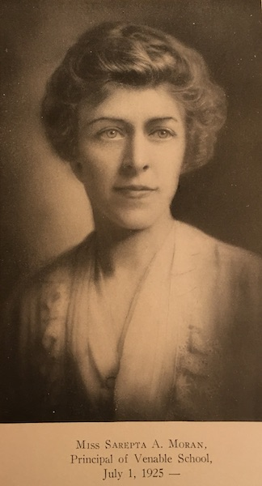

Photo of Moran from 1936 McGuffey Reader Supplement

The Daily Progress, Nov 10, 1961

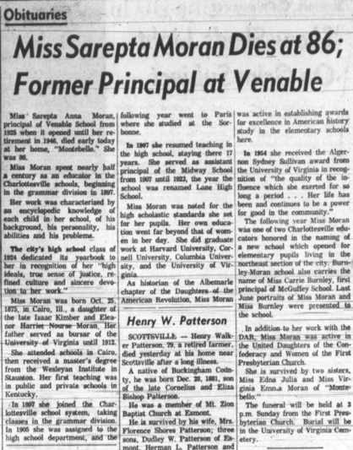

# Greenbrier Elementary (1962)

*Constructed in 1962, Greenbrier Elementary is named for its neighborhood, a residential area in the north of Charlottesville.*

http://charlottesvilleschools.org/greenbrier/us/

See Cvillepedia entries on [Greenbrier Elementary School](https://www.cvillepedia.org/Greenbrier_Elementary_School) and [Greenbrier neighborhood](https://www.cvillepedia.org/Greenbrier_neighborhood)

Greenbrier Elementary is named for the neighborhood in which the school is located.

# 

# Walker Upper Elementary (1966)

*Named in honor of Haswell Hunter Walker, head of the mathematics department at Lane High School, Walker School opened in August 1966 as one of two junior high schools in the City. (Buford School was the other.)*

<http://charlottesvilleschools.org/walker/us/>

See Cvillepedia entries for [Walker Upper Elementary School](https://www.cvillepedia.org/Walker_Upper_Elementary_School) and [Haswell Hunter Walker](https://www.cvillepedia.org/Haswell_Hunter_Walker)

Walker Upper Elementary is named for **Haswell Hunter Walker (1896-1992)**. Walker was born in Saluda, Middlesex County, Virginia. Walker was an educator in City schools for 42 years, primarily teaching math. Walker started at Midway High in 1924 teaching Mathematics and the Bible, was principal for three years from 1925-1928, then taught Mathematics there until 1966 (Midway High was renamed to Lane High in 1925). Walker Junior High School was named for him in the same year he retired, then later renamed Walker Upper Elementary School after a reconfiguration of the schools.

During Walker’s first year teaching at Midway, The Daily Progress on (Oct. 2, 1924) published this about him:

*“Mr. Walker is using unusually good methods in his Geometry classes. He has pupils to[sic] construct every figure about which they are studying before the proof is taken up. Getting pupils to do things and see things ensures clear understanding. Teachers sometimes forget that pupils have eyes and muscles as well as ears. Knowledge comes through the use of more than one sense.”*

During the desegregation of Charlottesville schools in 1958-1959, Walker was an informal advisor to the Parents’ Committee for Emergency Schooling (PCES), a white group that argued for the temporary continuation of private Segregation Academies as a way to transition into a desegregated public school and thereby counter the staunch segregationist group Charlottesville Education Foundation (CEF), which wanted either permanent public school segregation or permanent Segregation Academies. In *The Moderate’s Dilemma*, Andrew B. Lewis writes that Walker “tipped off the mothers to a secret meeting the CEF was holding with the Lane teachers in hopes of securing their participation in the segregationist initiative before the PCES had a chance to speak with them,” and thereby allowing the PCES to prevail against the CEF, preventing a more prolonged segregation of public schools.[10]

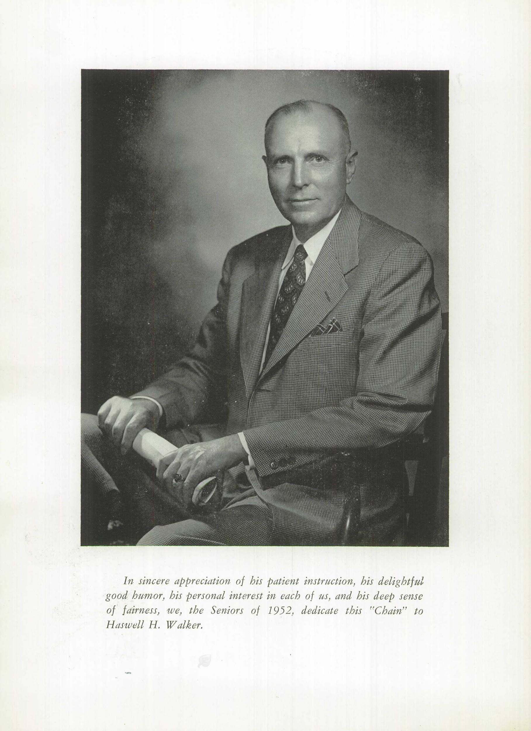

From 1952 Lane High Yearbook

# Buford Middle (1966)

*Named in honor of Florence Buford, who served as principal of Clark Elementary for 33 years, Buford Middle School opened in August 1966 as one of two junior high schools in the City. (Walker School was the other.)*

<http://charlottesvilleschools.org/buford/about-buford/>

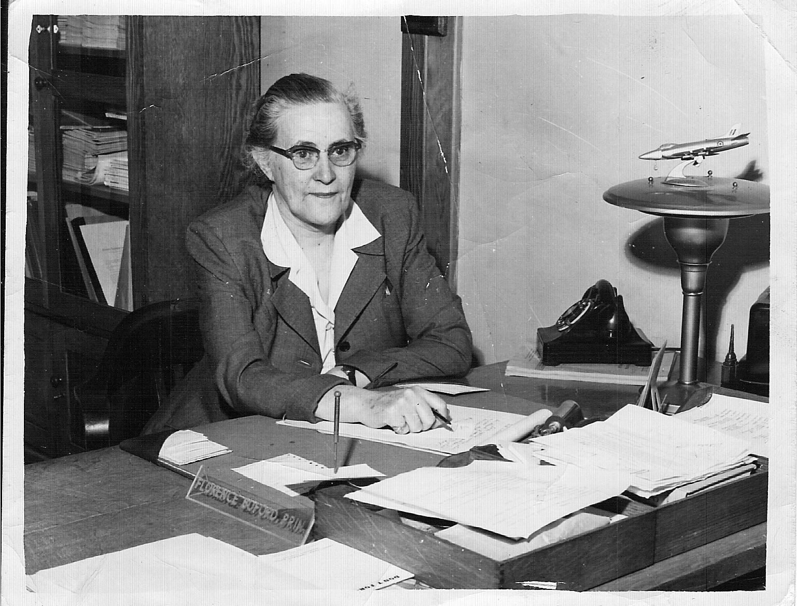

See Cvillepedia entries for [Buford Middle School](https://cvillepedia.org/Buford_Middle_School) and [Florence Buford](https://cvillepedia.org/Florence_Buford)

Buford Middle School is named for **Florence De Launey Buford (1893-1974)**. Buford taught History at Lane High starting in 1927. In 1931, she moved to the new Clark Elementary, and was principal there until her retirement in 1964.

Buford was born in 1893, in Lawrenceville, Brunswick County, Virginia. Her grandfather, Francis Emmet Buford, served as a Captain of a Brunswick Company in the Confederate Army during the Civil War. Florence Buford graduated from Farmville College (now Longwood College) in 1913. She then attended Columbia University and UVA, where she earned a Master’s degree in Political Science.

She participated in numerous community service organizations, including president of the State Department of Elementary Principals, vice chair of the Charlottesville-Albemarle Library Board (which would later merge with the JMRL), a member of the city welfare department advisory board, a member of Delta Kappa Gamma, and the all-white Lychnos Society, vice president of the Community Chest, president of the Mental Hygiene Society of Charlottesville, a member of the Salvation Army advisory board, and on the board of the Civic League of Charlottesville and Albemarle.

The Daily Progress, April 8, 1974, obituary

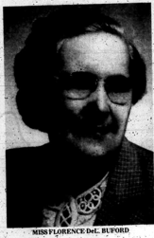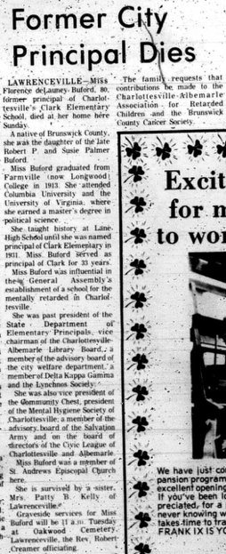

# Jackson-Via Elementary (1969)

*Jackson-Via Elementary School was named for two Charlottesville educator-leaders: Nannie Cox Jackson and Betty Davis Via.  The school opened in name in 1969, though during the first year, students were housed at Clark and Johnson Elementaries.  In 1970, the new building was ready for students.*

About Jackson-Via Elementary*,* <http://charlottesvilleschools.org/jackson-via/us/>

See Cvillepedia entries for [Jackson-Via_Elementary_School](https://www.cvillepedia.org/Jackson-Via_Elementary_School),

[Nannie_Cox_Jackson](https://www.cvillepedia.org/Nannie_Cox_Jackson), and [Betty_Davis_Via](https://www.cvillepedia.org/Betty_Davis_Via).

Jackson-Via Elementary is named for **Nannie Cox Jackson** and **Betty Davis Via**. Jackson-Via was the city’s first school building that was planned and built as a desegregated school. It was dually-named for both a Black educator and a white educator.

**Nannie Cox Jackson (1865-1953)** was a teacher for 46 years, 25 of which were at the Jefferson School, from which she retired in 1939. She is a descendant of the Hemings family though her grandmother [Nancy Colbert Scott](https://www.monticello.org/getting-word/people/nancy-colbert-scott).

Mrs. Jackson’s contributions to the schools and community are documented extensively in *Pride Overcomes Prejudice: A History of Charlottesville’s African American School* by Dr. Andrea N. Douglas, et al. She co-owned the first Black-run billboard company, and was one of the largest property holders in the area, renting at affordable rates to Black families across the city.

**Betty Davis Via (1901-1993)** was an educator in the city schools from 1927 to 1965. She taught at Venable Primary until becoming principal in 1945, and then was principal of the new Johnson Elementary for 10 years after it opened in 1955.

Via was born in Clifton Forge, Virginia. She received her Bachelor’s degree from State Teachers College at Harrisonburg, at what would later become James Madison University. She was a descendant of John Penn, a signer of the Declaration of Independence who enslaved Black people, and she was an active member in the Daughters of the American Revolution.

Upon her death, she was praised by Booker T. Reaves**[11]**:

*“She had an excellent personality, and was liked by all of those who worked with her. She liked her teachers and she liked the people she worked with. As a matter of fact, I don’t remember any conflicts involving her in all that time.”*

Via wrote several children’s books, including *Monticello Scrapbook* (1938), *Young Tom Jefferson’s Adventure Chest* (1942), *Scotchtown Tale* (1946), *Monticello’s Animal Kingdom* (1967)*, Thomas Jefferson and The Indians* (1969)*,* and *Sunshine and Shadows over Little Mountain* (1982), and numerous children’s stories, including *The Fourth-of-July Goose: A Monticello Story.*

Her books frequently perpetuate the “happy slave” myth; they refer to enslaved people simply as “servants,”; they use racist archetypes for Indigenous and African American characters (e.g., “grinning negro boy”, “old Mammy”); they use an imagined dialect for the dialogue of those characters; and they use what we now consider racial slurs, such as “negro,” “Injuns,” “redskin,” and “squaw.”

The book *Young Tom Jefferson’s Adventure Chest* contains passages such as the following:

*“‘Marse Tom,’ he gasped. ‘Look at dis here. I heered a bobwhite call and den it come flyin' through de air and stick right in a stump near de woodpile whar I'se asittin'. Marse To, it's Injuns. Is we gwine to be attacked?’”* (p. 178)

In the preface of *Monticello Scrapbook* (1938), Via states:

*“The events included in the Monticello Scrapbook are historically authentic. In order to make the stories more alive I have in some cases related what the characters might have said and described the reactions which they might have experienced to well known situations.”*

The following is a selection from the story “Home Again” in *Monticello Scrapbook*, describing Thomas Jefferson's return to Monticello after having served as a diplomat in France. It was around this time that Jefferson engaged with Sally Hemings.

Here is a selection from “Home Again,” *Monticello Scrapbook*:

It was the day before Christmas eve, 1789. For weeks there had been great Christmas preparations at Monticello. Pudding and frosted cakes had been made. Every room had been dusted and polished until the beautiful furniture and floors fairly shone. The children of the servants had made holly wreaths for the windows and hauled pine logs for the fireplaces. Bright turbans and gay aprons had been made ready and now they were donned in great excitement. For weeks the word had passed around “Marster's comin’,” “Marse Tom's comin’!” “Miss Martha and Miss Mary's comin’!”

And at last the day had arrived and Mr. Jefferson and his two daughters were returning home after an absence of Europe of five years.

Mr. Jefferson had written to his overseer the news of his return and the overseer had told the negroes. Upon their request the 23rd was declared a holiday in honor of the master's home coming and all of them had gathered from Mr. Jefferson's farms. No one wanted to miss the happy event. Old and young, women and children gathered on this hillside. Singing and shouting and calling to each other, they grew impatient with waiting and walked down the mountain to meet the carriage-and-four at Shadwell, Mr. Jefferson's birthplace. Eagerly they vied with one another to be the first to see the beloved face. How they cheered and cried and sang when they saw him! Crowding around the carriage they tried to touch his hands or feet or even his coat. Smiling, the master greeted them heartily, calling each by name. In the merry confusion, they unhitched the horses and lining up beside the carriage pole, pulled it themselves up to the beautiful portico of Monticello. One by one they quieted down. Many an eye was moist with memories of other days when Mr. Jefferson had brought his bride to Monticello.

“Miss Martha done growed up, bless de Lawd,” exclaimed an old Mammy standing near, “An’ look at Miss Mary, ain’t she beautiful?” called out another. And Maria, now in her 11th year, was more beautiful and lovable than ever. Martha was a tall and stately young lady of seventeen.

Their charm and beauty and lovely French clothes overawed the servants, and they fell back to let them enter. Up the front steps the master went with a beloved daughter on each arm, and Martha Jefferson walked across her father's threshold knowing that she would be more than ever his companion and the mistress of Monticello.

The Daily Progress, Aug 21, 1993, Obituary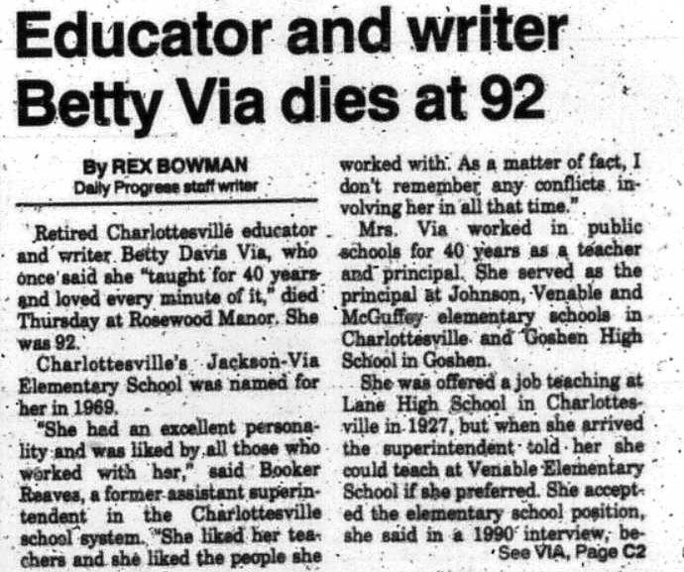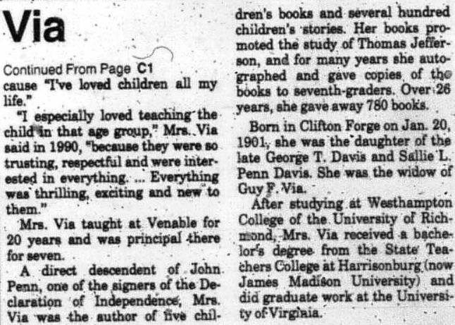

# Charlottesville High (1974)

*Built in 1974, Charlottesville High School replaced the historic Lane High School, which now serves as the Albemarle County Office Building. Lane High was built in 1939 but shut its doors in 1958 as part of the state’s massive resistance to racial integration. Lane High, along with Venable Elementary, were the first Charlottesville schools to be integrated when the “Charlottesville Twelve” entered the schools on September 8, 1959.*

--About Charlottesville High School <http://charlottesvilleschools.org/chs/us>

See Cvillepedia entry for [Charlottesville High School](https://www.cvillepedia.org/Charlottesville_High_School)

Charlottesville High is named for the city, which itself is named for **Charlotte of Mecklenburg-Strelitz**, queen consort of King George III.

Charlottesville High School was also the name of the first white public (though not free) high school in the city, in existence from 1877-1882.

# Lugo-McGinness Academy (2014)

*After a long history of alternative education, Charlottesville City Schools moved the program to a new, renovated facility in 2014.  At that time, the program was renamed Lugo-McGinness Academy in honor of Alicia Lugo and Rebecca F. McGinness, two longtime Charlottesville educators, community leaders, and child advocates.  Alicia Lugo attended Charlottesville schools during segregation and then graduated from Hampton University.  She returned to Charlottesville, where she taught and then served eleven years on the Charlottesville City School Board, including five years as board chair.  Also a Charlottesville native, Rebecca Fuller McGinness attended Hampton and taught at the now-closed, then-segregated Jefferson School for more than forty years. Both women set a high standard of excellence which the faculty and staff of Lugo-McGinness strive to achieve.*

-- Lugo-McGinness Academy Program History <http://charlottesvilleschools.org/lma>

See Cvillepedia entries for [Lugo-McGinness Academy](https://www.cvillepedia.org/Lugo-McGinness_Academy), [Alicia Inez Bowler Lugo](https://www.cvillepedia.org/Alicia_Inez_Bowler_Lugo), and [Rebecca Fuller McGinness](https://www.cvillepedia.org/Rebecca_Fuller_McGinness).

**Lugo-McGinness Academy** is named for **Alicia Inez Bowler Lugo (1941-2011)**and **Rebecca Fuller McGinness (1892-2000)**. Lugo-McGinness Academy was the first City school named for a person in 45 years. A primary reason for choosing these two distinguished individuals was not only to honor them, but also to collaterally recognize the significant and long-overlooked contributions of numerous American American residents to the schools and broader community.

**Alicia Lugo** was born in Charlottesville. She attended the Black-only Jackson P. Burley High School, then graduated from Hampton Institute (now Hampton University).  She served as a teacher and administrator in City schools for several years, then on the Charlottesville City School Board for 11 years, including five as chair. She served on numerous local Boards of Directors and received numerous awards in recognition of her distinguished career of service to the community.

**Rebecca McGinness** was born in Charlottesville. She attended the Black-only Jefferson Grade School through 8th grade, then at 16 years old, went to the Hampton Normal and Agricultural Institute (now Hampton University), where she completed both high school and college. She then returned to the Jefferson School and taught there for over forty years.

# City Public Schools, 1920-1921

This page is from a supplement to the McGuffey Reader about the Charlottesville school district, edited by Dr. Johnson in 1936. 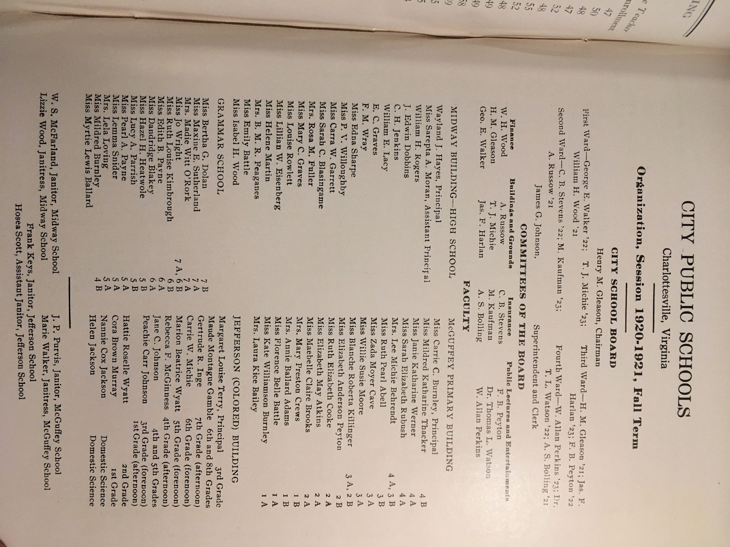

* James G. Johnson, Superintendent and Clerk
* Miss Sarepta A. Moran, Assistant Principal, Midway High School
* Miss Carrie C. Burnley, Principal, McGuffey Primary Building
* Mrs. Rebecca F. McGuiness, 4th Grade (afternoon, Jefferson (Colored) Building
* Mrs. Nannie Cox Jackson, Domestic Science, Jefferson (Colored) Building

# References

Bryant, Florence C. *Rebecca Fuller McGinness: A Lifetime: 1892-2000*

Buck, James H., Jr. *Belmont: The History of a Neighborhood*, <https://www.cvillepedia.org/images/19800501-buck-history-of-belmont.pdf>

*City of Charlottesville Blue Ribbon Commission on Race, Memorials, and Public Spaces Report to City Council* https://www.charlottesville.org/home/showdocument?id=49037

Douglas, Andrea N. et al. *Pride Overcomes Prejudice: A History of Charlottesville's African American School.*

English, W. H. *Conquest of the country northwest of the river Ohio, 1778-1783; and life of Gen. George Rogers Clark.* https://archive.org/details/cu31924092886104

Jefferson School Oral History Project, 975.5481 Jefferson in JMRL

Johnson, J. G. *Education Pamphlets: Vol. 3.* 1936. History of McGuffey school, 1915-1936. History of Venable school, 1922-1936. History of George Rogers Clark school, 1928-1936. <https://search.lib.virginia.edu/catalog/u2722115>

Sidwell, Robert W. *Sacrificing for the Lost Cause: General Robert E. Lee's Personal Staff.* <http://rave.ohiolink.edu/etdc/view?acc_num=kent1522934821626724>

Sunshine, Daniel. “Charles S. Venable (1827–1900).” *Encyclopedia Virginia*. Virginia Foundation for the Humanities, 22 Feb. 2018. Web. 28 Aug. 2019. <https://www.encyclopediavirginia.org/Venable_Charles_S_1827-1900>

William Holmes McGuffey. (n.d.). In Wikipedia. Retrieved Sept 12, 2019, from <https://en.wikipedia.org/wiki/William_Holmes_McGuffey>

# Document Revision History

|  |  |
| --- | --- |
| Date | Description |
| 2019 Oct 29 | Initial Publication |
|  |  |
|  |  |

1. Sunshine, Daniel. “Charles S. Venable (1827–1900).” *Encyclopedia Virginia*. Virginia Foundation for the Humanities, 22 Feb. 2018. Web. 28 Aug. 2019. <https://www.encyclopediavirginia.org/Venable_Charles_S_1827-1900>
2. William Holmes McGuffey. (n.d.). In Wikipedia. Retrieved Sept 12, 2019, from <https://en.wikipedia.org/wiki/William_Holmes_McGuffey>
3. Sidwell, Robert W. *Sacrificing for the Lost Cause: General Robert E. Lee's Personal Staff*
4. Ibid.
5. Ibid.
6. Ibid.
7. English, W. H. *Conquest of the country northwest of the river Ohio, 1778-1783; and life of Gen. George Rogers Clark, Volume I.* p. 47
8. Buck, James H., Jr. *Belmont: The History of a Neighborhood*, https://www.cvillepedia.org/images/19800501-buck-history-of-belmont.pdf
9. United Daughters of the Confederacy, Virginia Division, Papers, Accession #11331, Special Collections Department, University of Virginia Library, Charlottesville, Va.
10. *The Moderates' Dilemma: Massive Resistance to School Desegregation in Virginia*, Matthew D. Lassiter and Andrew B. Lewis, eds.
11. Booker T. Reaves was principal of the Jefferson School for many years. When Charlottesville integrated in the 1960s, Superintendent George Tramontin named him the district's first African-American Assistant Superintendent. After Tramontin was fired, largely because of his role in integrating the schools, Reaves became the district's first African-American Acting Superintendent. The Media Center at Charlottesville High is named in honor of him.